**Professional Growth Plan**

DISTRICT PRINCIPALS, PRINCIPALS, VICE PRINCIPALS

*Name: Click or tap here to enter text.*

*Position: Click or tap here to enter text.*

*School: Click or tap here to enter text.*

*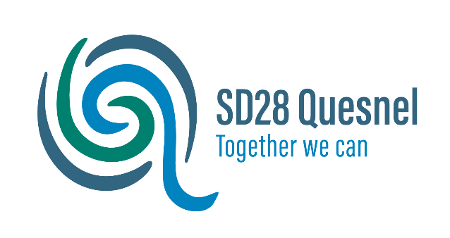Date: Click or tap here to enter text.*

# Purpose

Annually, District Principals, Principals and Vice Principals will work through a process to identify professional growth goals, which are guided by the BCPVPA Leadership Standards. The purpose of the Professional Growth Plan is to guide professional learning and growth, and is designed to encourage reflective practice. In addition, the process is designed to encourage collegial conversations; examination and application of current research; innovation and inquiry; and the opportunity to build leadership capacity. The QDPVPA growth plan process will serve as a Performance Review as per the attached timeline.

# Professional Growth Plan Outline

1. Start with Self-Assessment - [BCPVPA Leadership Standards Workbook.](https://www.bcpvpa.org/resources/publications/leadership-standards-for-p-vp-in-bc)
2. Gather evidence to support the Self-Assessment.
3. Review evidence and results and reflect on next steps.
4. Develop a minimum of (1) goal based on the evidence and Self-Assessment, aligning the goals with the District’s Strategic Plan, the School Growth Plan.
5. Complete the template (attached), providing the following information:
   1. Rationale for the Goals and evidence from your practice
   2. Alignment to the BCPVPA Leadership Standards, District’s Strategic Plan and School Plan.
   3. Strategies and/or structures to achieve the goals
   4. Professional learning opportunities you will use to achieve the goals
   5. Indicate how will you monitor your progress throughout the year related to the achievement of your goals
6. Meet with the Superintendent or designate to share and review your Professional Growth Plan according to the attached timeline. If helpful, you may choose to send occasional updates and/or artifacts to the Superintendent or designate throughout the year, to keep them apprised of your progress or keep them in your portfolio for the year end meeting.

# Goals

Your goals should be connected to the BCPVPA Standards and consider the First People’s Principles of Learning listed below. Goals should be aligned with the District’s Strategic Plan and/or School Growth Plan. To guide you with the development of the Goals, use the Self-Assessment tool in the [BCPVPA Leadership Standards Workbook.](https://www.bcpvpa.org/resources/publications/leadership-standards-for-p-vp-in-bc)

**Domain One – Ethical Leadership**

* Standard 1: Leading a Community of Caring and Learning
* Standard 2: Decision Making

**Domain Two – Instructional Leadership**

* Standard 3:
  + - Leading a Culture of Learning – Leading the Learning
    - Leading a Culture of Learning – Collaborative Practice
    - Leading a Culture of Learning – Learners at the Centre
    - Leading a Culture of Learning – Innovation and Inquiry
* Standard 4: Curriculum, Instruction and Assessment

**Domain Three – Relational Leadership**

* Standard 5: Metacognitive Capacity
* Standard 6: Interpersonal Capacity
* Standard 7: Cultural Leadership
* Standard 8: Community Building

**Domain Four – Organizational Leadership**

* Standard 9: Management and Administration

**THE FIRST PEOPLES PRINCIPLES OF LEARNING**

**We believe that Learning**

* Ultimately supports the well-being of the self, the family, the community, the land, the spirits and the ancestors.
* Is holistic, reflexive, reflective, experiential and relational.
* Involves recognizing the consequences of one’s actions.
* Involves generational roles and responsibilities.
* Recognizes the role of indigenous knowledge.
* Is embedded in memory, history and story.
* Involves patience and time.
* Requires exploration of one’s identity.
* Involves recognizing that some knowledge is sacred and only shared with permission and/or in certain situations.

# Goal (1)

|  |  |  |
| --- | --- | --- |
| **BCPVPA Domain** | **BCPVPA Standard(s)** |  |
|  |  | |
| Alignment to District’s Strategic Plan and/or School Plan: | | |

**Rationale for Goal (1)**

Outline the rationale for this goal and include in your rationale a few pieces of evidence, material or data from your context that is connected to, and supports your goal.

|  |  |
| --- | --- |
| **Strategies to achieve Goal (1) Indicators of Success** | |
|  |  |

# Goal (2)

|  |  |  |
| --- | --- | --- |
| **BCPVPA Domain** | **BCPVPA Standard(s)** |  |
|  |  | |
| Alignment to District’s Strategic Plan and/or School Plan: | | |

**Rationale for Goal (2)**

Outline the rationale for this goal and include in your rationale a few pieces of evidence, material or data from your context that is connected to, and supports your goal.

|  |  |
| --- | --- |
| **Strategies to achieve Goal (2) Indicators of Success** | |
|  |  |

# Reflections

|  |  |
| --- | --- |
| **Successes** |  |
| **Challenges** |  |
| **Considerations for next year** |  |