

Enter Date Published

Choose an item.

School Growth Plan

Enter Year

*School growth plans are aligned with the District's* [*Strategic Plan*](https://bcsd28.civicweb.net/document/70641/) *with priority measures represented in the Framework for* [*Enhancing Student Learning Report*](https://bcsd28.civicweb.net/document/70521/)*.*

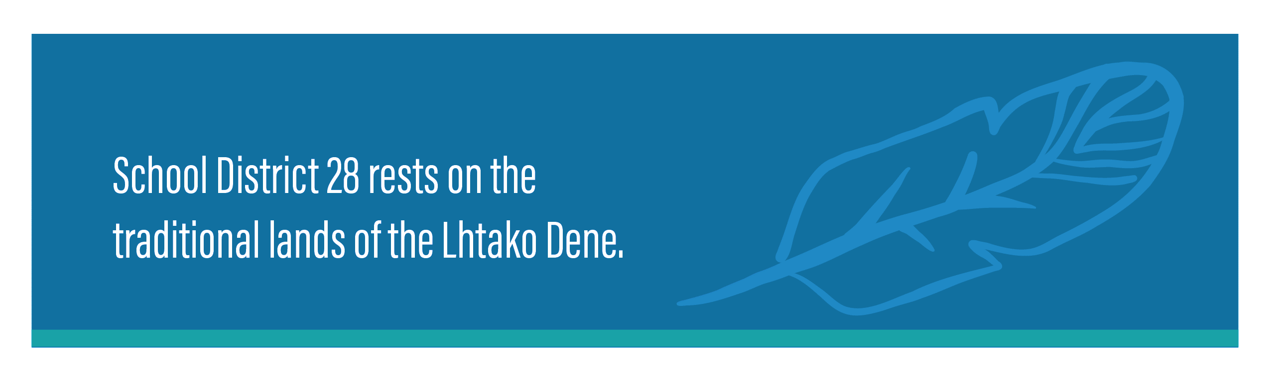



Picture



Picture

Click or tap here to enter text.

**OUR SCHOOL**

THE STORY/JOURNEY

(such as)

*What our students like about our school…..*

*PAC Information …..*

*What our parents say about our school….*

*How you consult with community…*

**SCHOOL**

**INFORMATION**

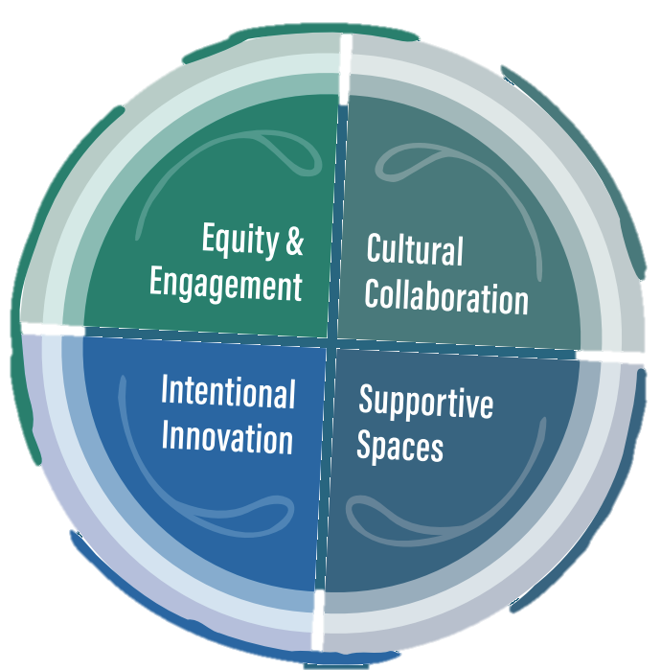

SUPPORTIVE SPACES

Click or tap here to enter text.

RATIONALE

Click or tap here to enter text.

Click or tap here to enter text.

ACTIONS / STRATEGIES:

Click or tap here to enter text.

MEASURES:

Click or tap here to enter text.

SPEAK TO THE DATA:



EQUITY & ENGAGEMENT - LITERACY

Click or tap here to enter text.

RATIONALE

Click or tap here to enter text.

Click or tap here to enter text.

ACTIONS / STRATEGIES:

Click or tap here to enter text.

MEASURES:

Click or tap here to enter text.

SPEAK TO THE DATA:



EQUITY & ENGAGEMENT - NUMERACY

Click or tap here to enter text.

RATIONALE

Click or tap here to enter text.

Click or tap here to enter text.

ACTIONS / STRATEGIES:

Click or tap here to enter text.

MEASURES:

Click or tap here to enter text.

SPEAK TO THE DATA:



CULTURAL COLLABORATION

Click or tap here to enter text.

RATIONALE

Click or tap here to enter text.

Click or tap here to enter text.

ACTIONS / STRATEGIES:

Click or tap here to enter text.

MEASURES:

Click or tap here to enter text.

SPEAK TO THE DATA: