

Choose an item.

School Growth Plan

Enter Year

*School growth plans are aligned with the District's* [*Strategic Plan*](https://bcsd28.civicweb.net/document/70641/) *with priority measures represented in the Framework for* [*Enhancing Student Learning Report*](https://bcsd28.civicweb.net/document/70521/)*.*

Enter Date Published

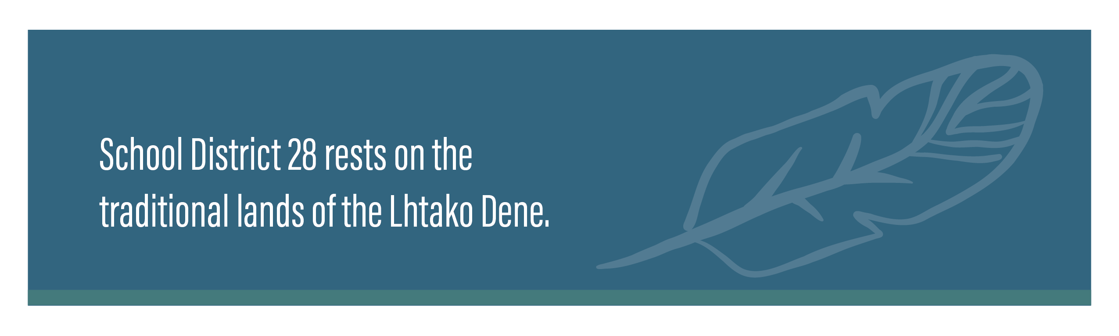

**OUR SCHOOL**

**STORY / JOURNEY**

Click or tap here to enter text.



(such as)

*What our students like about our school…..*

*PAC Information …..*

*What our parents say about our school….*

*How you consult with community…*

SCHOOL INFORMATION





**SUPPORTIVE SPACES**

Click or tap here to enter text.

**RATIONALE**

Click or tap here to enter text.

Click or tap here to enter text.

**ACTIONS / STRATEGIES**

Click or tap here to enter text.

**MEASURES**

Click or tap here to enter text.

**SPEAK TO THE DATA**

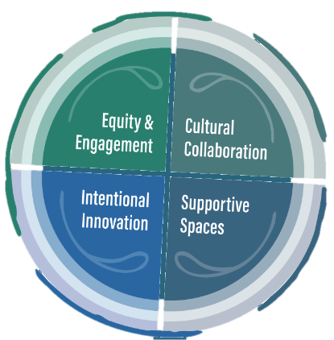

**EQUITY & ENGAGEMENT - LITERACY**

Click or tap here to enter text.

**RATIONALE**

Click or tap here to enter text.

Click or tap here to enter text.

**ACTIONS / STRATEGIES**

Click or tap here to enter text.

**MEASURES**

Click or tap here to enter text.

**SPEAK TO THE DATA**



**EQUITY & ENGAGEMENT - NUMERACY**

Click or tap here to enter text.

**RATIONALE**

Click or tap here to enter text.

Click or tap here to enter text.

**ACTIONS / STRATEGIES**

Click or tap here to enter text.

**MEASURES**

Click or tap here to enter text.

**SPEAK TO THE DATA**



**CULTURAL COLLABORATION**

Click or tap here to enter text.

**RATIONALE**

Click or tap here to enter text.

Click or tap here to enter text.

**ACTIONS / STRATEGIES**

Click or tap here to enter text.

**MEASURES**

Click or tap here to enter text.

**SPEAK TO THE DATA**

